Lab No | : | 10
Name of the Lab | : | Implementation of Round Robin scheduling algorithm
ID | : | IT-17035
Objective | : | (1) What is Round Robin Scheduling Algorithm?  (2) How to implementation in C?

(1) What is Round Robin Scheduling Algorithm ?
Ans:
Round Robin is a CPU Scheduling Algorithm where each process is assigned a fixed time slot in a cyclic way.
- It is simple, easy to implement, and starvation-free as all processes get fair share of CPU.
- One of the most commonly used technique in CPU scheduling as a core.
- It is preemptive as processes are assigned CPU only for a fixed slice of time at most.
- The disadvantage of it is more overhead of context switching.

(2) How to implementation in C?
Ans :
Source code:
#include<stdio.h>
int main()
{
int i,j,n,time,remain,flag=0,ts;
int sum_wait=0,sum_turnaround=0,at[10],bt[10],rt[10];
printf("Enter no of Processes : ");
scanf("%d",&n);
remain=n;
for(i=0; i<n; i++)
{
printf("Enter arrival time and burst time for Process P%d :",i+1);
scanf("%d",&at[i]);
scanf("%d",&bt[i]);
rt[i]=bt[i];
}
printf("Enter time slice");
scanf("%d",&ts);
printf("\n\nProcess\t|Turnaround time|waiting time\n\n");
for(time=0,i=0; remain!=0;)
{
if(rt[i]<=ts && rt[i]>0)
{
time+=rt[i];
rt[i]=0;
flag=1;
}
else if(rt[i]>0)
{
rt[i]-=ts;
time+=ts;
}
if(rt[i]==0 && flag==1)
{
remain--;
printf("P[%d]\t|\t%d\t|\t%d\n",i+1,time-at[i],time-at[i]-bt[i]);
sum_wait+=time-at[i]-bt[i];
sum_turnaround+=time-at[i];
flag=0;
}
if(i==n-1)
i=0;
else if(at[i+1]<=time)
i++;
else i=0;
}
printf("\nAvg sum_wait = %f\n",sum_wait*1.0/n);
printf("Avg sum_turnaround = %f",sum_turnaround*1.0/n);
return 0;
}

Output :
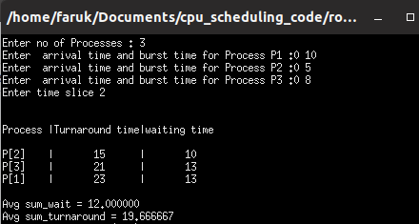

Conclusion :
By doing this lab, I have implemented Round Robin scheduling algorithm.
First of all, I face some problem,when I do this . But later I solve these problem .

